Setting up Excel / Mainframe Macros

Contents:
[1]: Preparing Excel for macro enabled workbooks
[2]: Setting up the Mainframe macro
[3]: Setting up the Excel macro

[1]: Preparing Excel for macro enabled workbooks
(You must do once when first setting up a laptop. All excel files must be closed before starting.)

If you are not sure if this was done at least once on your laptop, just go through it again and make sure the options listed are there.
- Open a blank excel. Go to File -> click Excel Options
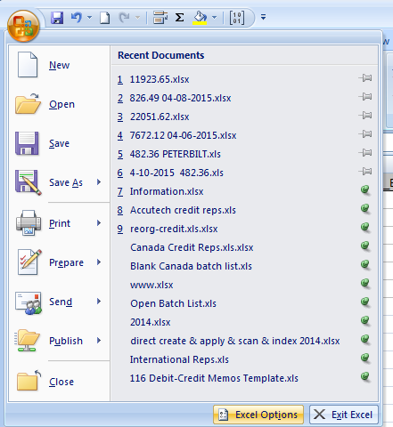
- Click “Popular”, click the “Show Developer tab in the Ribbon” check box:
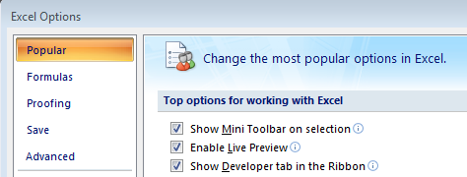

- Click “Save”, change the first combo box for “Save files in this format” to “Excel Workbook (*.xlsx)”:
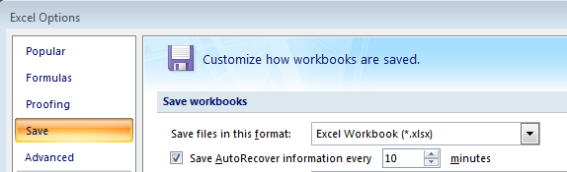
- Click “Trust Center”, Click “Trust Center Settings”:
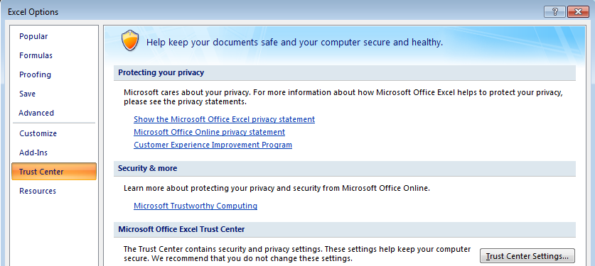
- A new window will pop up called Trust Center. Click “Macro Settings”, click the circle “Enable All Macros”:
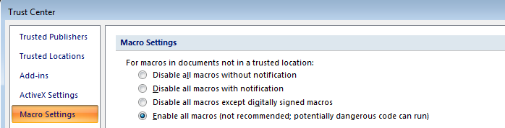
- Click Ok for the Trust Center window.
- Click Ok for the Excel Options Window.
- Done.
[2]: Setting up Mainframe Macro
- Open any mainframe window.
- Right click the macro number you want to set up (this one is using #4) and click “Edit macro”.
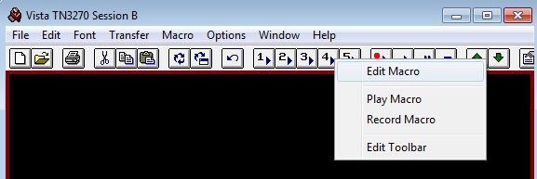
- There should be a note pad window that pops up with a name like “user#.mac”, Delete everything inside of it:
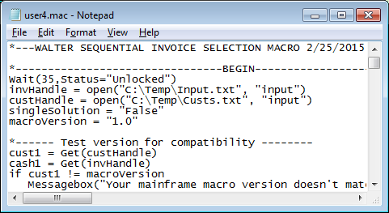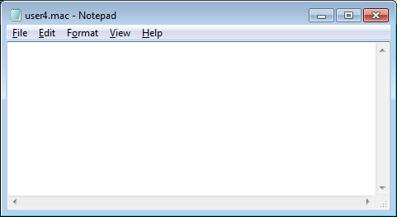
- Go to Cash folder “J:\CASH\Walter\Mainframe Macro” and open “Mainframe_Sequential_Macro v2.txt”:
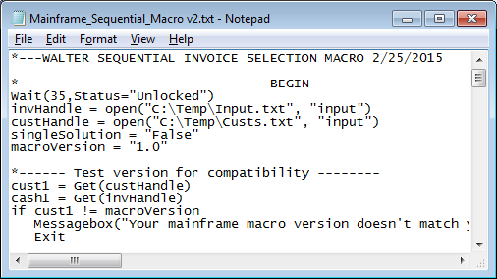
- Select all (Ctrl + A) and copy (Ctrl + C), then click in the emptied “user#.mac” notepad and paste. On the “user#.mac” window, click File, click Save and then close the “user#.mac” file.
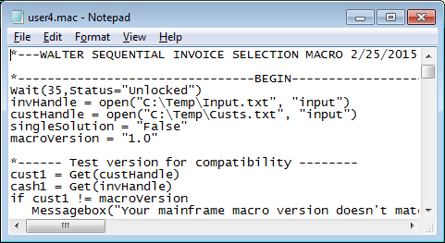
- Close the “Mainframe_Sequential_Macro v2.txt” but do not save it (it shouldn’t ask this but click no if it does.)
- Done.
[3]: Setting up Excel Macro
1. Go to the folder in J drive “J:\CASH\Walter\Macros” and open “New_Invoice_match_Macro v2.xlsm”
- Go to File -> click Excel Options
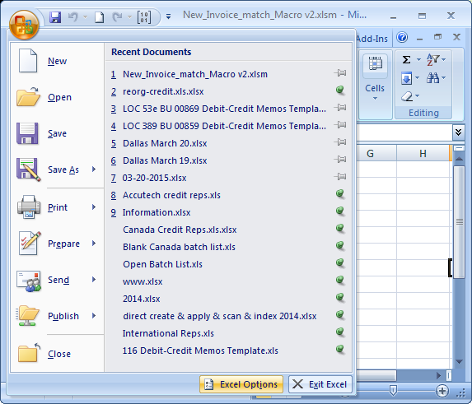
- Click Customize, then change the combo box to show “Macros”:
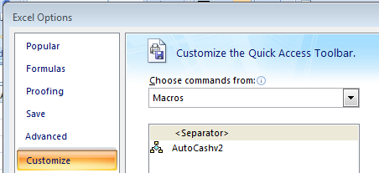

- (Skip this step if this is the first time setting up this excel macro) Make sure you remove any old button on the right column first by clicking the name, then click the button labeled “Remove”:
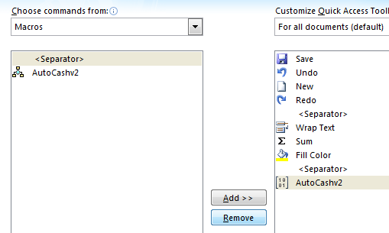
- Click the macro on the left side (this example is setting up macro with name “AutoCashv2”), then click “Add>>”:
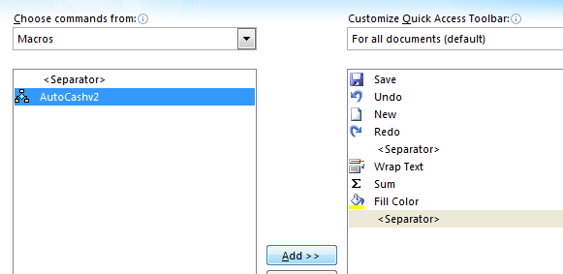
- Click “Modify” to change the icon of the macro. Click any icon you want the button to be, then click OK:
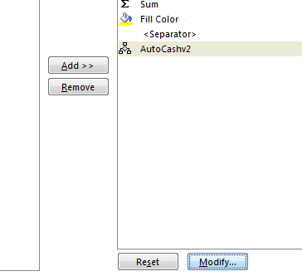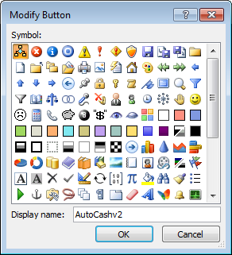
- Click OK on the Excel Options Window.
- Your new macro should be on the top bar whenever you open Excel now. It will have the icon you chose:
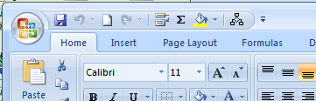

- Done. You can close the excel file and the c: window now. Do not save if it asks you to save.
Note: You do not have to open the excel macro file to use it. It will open automatically whenever you press that button.

